|  |
| --- |
| CS 371M |
| Ambient Nights |
| Application Prototype |

|  |
| --- |
| Jeffrey Li JL37656  Phillip Pham PNP248 |
|  |

## **High Priority UI Screens**

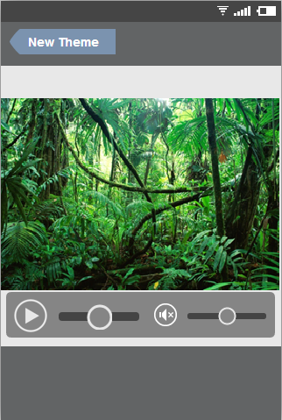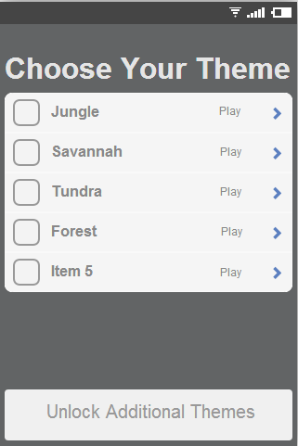Initial Selection Screen Currently Playing Screen

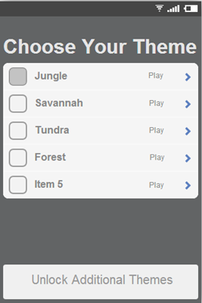Selection Screen (Theme Selected)

The app starts off on the Initial Selection Screen. If a theme is selected, the button will be darkened. Once chosen, the Currently Playing Screen will appear with typical media player features.

# **Low** Priority UI Screens

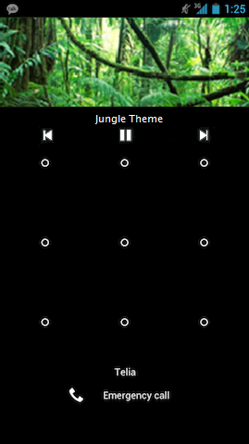Potential Lock Screen Widget

The lock screen widget is a low priority feature that would allow you to view the theme from a locked screen (similar to Spotify). This way you can keep your phone locked and darkened at night and still be able to change themes if you so choose (or quickly turn it off).

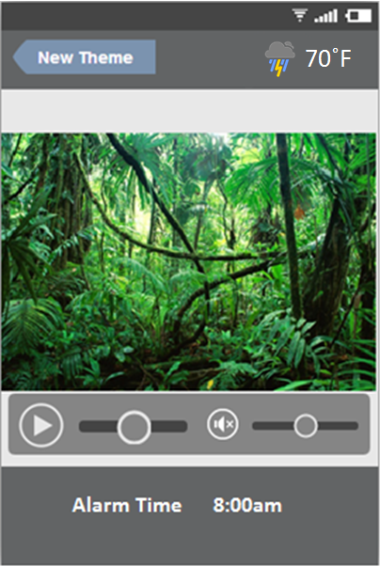Alarm Clock Integrated Screen

This is a potential improved version of the playing screen that would potentially incorporate both the weather and alarm clock applications. This would provide the user with more information while still on the now playing screen, and would require less interfacing with the alarm application while still providing soundness of mind.